Stephen Seyler
BID Executive Security Director

SUMMARY FOR 10-11-10 THROUGH 12-05-10

This report takes us through week 49 of this year. Our goal remains the improvement of the quality of life in the BID areas. We continue to expand our role and evolve as we address new challenges. We have become increasingly proactive in responding to new trends and problems. An example is a situation that developed at the Los Angeles Film School. Each month new students arrive and are issued lap top computers. We learned that about a dozen of these computers had been stolen. We put together a power point presentation with the help of Joe Mariani. We then assisted Joe in addressing the incoming students with a security briefing. We gave them information that should help make their stay in Hollywood safe and productive.

We are deeply involved with the Homeless Outreach, Business, and Law Enforcement communities and are constantly on the lookout for new groups or individuals to partner with that share our goals.

EVENTS OF INTEREST:

On 10-11-10, I participated on a field trip with Los Angeles Sheriff Sgt. Salvador ‘Chuck’ Becerra Jr. He is with the Transit Services Bureau and is replacing Lt. Rodriguez. Kerry Morrison, Joe Mariani, and Mike Harkins also participated. Chuck gave us a tour of the red and blue lines, his headquarters at the Gateway Plaza as well the Rail Operations Control Center (The Rock) in Lynwood. This is a state of the art facility where the trains are routed and monitored.

On 10-12-10, I attended a security meeting with a property owner in the Sunset BID. Kerry Morrison and the LAPD Senior Lead Officer for the area also attended. We came up with a joint plan to address the property owner’s concerns. This group effort is the model that we pursue whenever possible as it magnifies our impact.

After numerous delays, we finally deployed our Tasers starting on Monday (10-18-10) in both the HBID and SBID.

On 10-21-10, the Get Love Food Line moved from Vista Del Mar to the Church of the Blessed Sacrament. Our Officers stood by to maintain security during the transition.

On 10-28-10, the Chamber of Commerce had a ceremony where they buried a time capsule in the ground at Hollywood and Highland. Our Officers provided extra patrol for this event.

On 10-29-10, we had an Officer Appreciation luncheon for our team. We had recently crossed the 1000 arrest threshold for the fourth year in a row. HBID Committee

President Thad Hunter Smith made a nice speech thanking our Officers for their efforts. The bottle of Halloween Sangria he presented to each Officer didn’t hurt either. Kerry
Morrison and her staff also attended. We had about 8 Day Watch LAPD Officers share lunch with us as well as the entire swing shift (15 Officers).

On 10-29-10, BID Sgt. Patton saw a 28 year old woman named Nikita down on the sidewalk on Hudson just north of Hollywood Blvd. He pulled up to the curb, engaged his emergency flashers, and approached to see if she needed medical attention. He learned that she had just gotten out of the hospital and was homeless. She refused medical treatment, but it was clear that she needed help. Officers Baxter and Gordon arrived to assist. They parked behind Patton also engaging their emergency flashers.

Our Officers stayed with Nikita as they made several phone calls attempting to find a shelter for her. They contacted Sonny from Get Love who asked them if they could transport Nikita to the Church of the Blessed Sacrament so he could try to place her. Our Officers later transported Nikita to the Church so she could receive much needed assistance.

During this time, two men approached. One named Adam complained that we were parked illegally. He wanted to make a citizen’s arrest of our Officers. He likened our operation to Black Water operations in Iraq. The second man was named Toby. Our Officers explained why they were parked there, but Adam was not satisfied.

Officer Gordon called me (Seyler) and then put Adam on the phone. Adam told me about his complaint and I told him I would investigate it as always. Note that Adam has made several similar complaints in the past. He has complained when we stopped to help a man unconscious on the sidewalk and when arresting a robbery suspect. He has told me that he has every intention of making a private person’s arrest of a BID Officer whenever he sees a violation.

On 10-29-10, Joe Salazar and our Officers Mike and Mike participated in a workshop for area homeless youth along with the Legal Council’s Office. Our Officers informed the youth about their legal rights and how to handle themselves when dealing with the Police and security Companies.

We have recently come into contact with a new group of homeless youth. We have seen groups of 7 to 15 people. They call themselves the ‘Clown Posse” and they paint their faces white. They gather in groups and block the sidewalks in various locations including the McDonalds at Hollywood and Highland. The group is extremely hostile to BID Security and we foresee possible issues with them in the future.

On Saturday (11-13-10) Senior V/P Bill Farrar and I participated in Home Walk 2010. The lovely Emily Rose (my daughter) also walked with us. It is a 5k walk/fund raiser with the goal of ending homelessness. This is our forth year participating in this event. Kerry Morrison and her staff were present as always. Our team, Hollywood 4WRD, was

one of the top two groups in number of people walking and money raised. Eileen Getty and her crew were also a big part of the team. These are the types of events that all the above parties participate in on their own time in an effort to better this community.

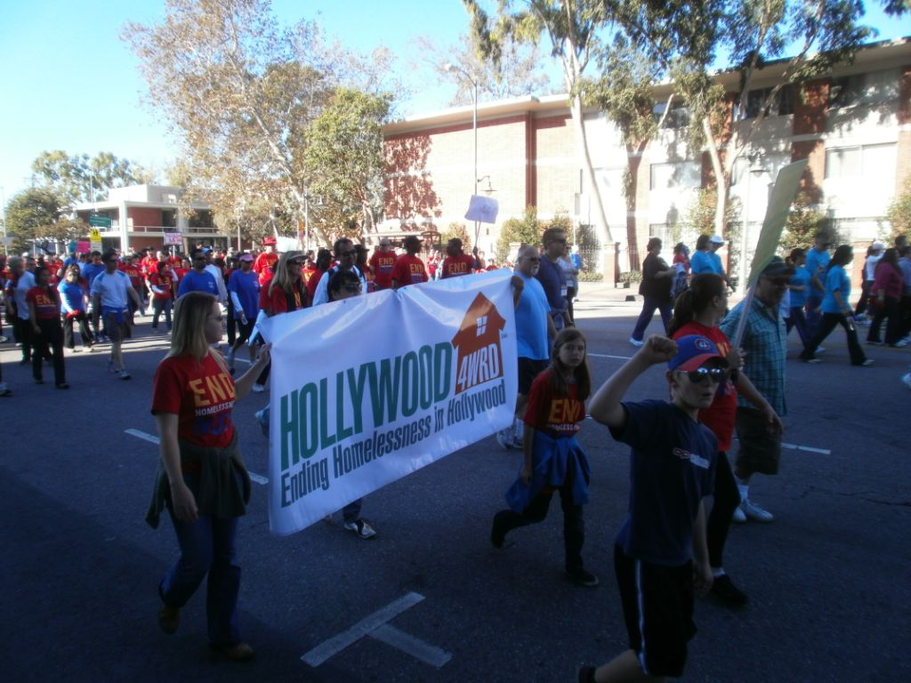

On 11-19-10, LAPD Captain Grimala attended our noon briefing and addressed our troops. Senior V/P Bill Farrar, CIM Executive Dan Chismire, and Kerry Morrison were in attendance. Captain Grimala presented Officers Mike Coogle and David Tesh with commendations for a Grand Theft arrest they assisted with on 11-10-10.

The Captain also had kind words for the entire team. She said she recently attended an eight hour training session where each Division was presented with realistic emergency scenarios that they needed to solve in real time. They were asked which community groups and resources they would call on and in what time frame. She and her command staff agreed that they would call in BID Security as soon as possible for assistance. These words were great to hear as we have worked very hard to build up this trust level.

On 11-24-10, we hosted a meeting in our office to address the escalating problems being caused by homeless people sleeping at the Greyhound Terminal. Joe Mariani represented Kerry Morrison while I did the same for BID Security. Greyhound Terminal Manager Lorena Navarrete and Regional Manager Ruth Ann Costa were in attendance. Tomasz Babiszliewicz and Jorge Guzman from PATH were there as well as LAPD Senior Lead Officers Danny Pasqueda, Maggie Dillard, and Irv Isabella.

We agreed on a plan to combine our limited resources to address the issue. We agreed to meet in the future to access the results and plan further actions if warranted.

On 11-25-10, we teamed up with LAPD and drove to the Greyhound Terminal located at 1715 Cahuenga. We advised and then stood by as 14 homeless people gathered up their belongings and left the scene.

On 11-30-10, I sent Supervisor Bob Reyes to meet with Lynne Guffee who manages the property at 1555 N. Vine. They have some security concerns. Lynne advised that her company (Windsor Management) took over the property about six months ago. The

property includes Borders, Game Shop, Bed, Bath, and Beyond and other stores and restaurants.

Bob learned of her concerns and suggested solutions. He also made arrangements for us to make a security presentation for the tenants at the property. Kerry Morrison’s office will also participate.

On 12-02-10, we sent two of our Officers to give a power point security presentation to the incoming class of students at the Los Angeles Film School. Joe Mariani also participated. We have done this in the past. We suggested that the school film the
presentation as a sort of class project. They could then show the film to students at future orientations if we are not available.

On 12-02-10, our Officers were at the LAPD Station where they met Dwayne. He was there reporting his black Lab as being stolen. He had left the dog tied to a tree at the Church of the Blessed Sacrament while he went inside to eat. The LAPD Desk Officer told Dwayne that if anyone could find the dog, it would be the BID Patrol.

One of our Officers remembered seeing long time homeless woman Nancy with a black dog earlier in the day. He tracked her down and learned that she had given the dog to a man named Greg who said he knew the owner. She took the dog because she thought it was hungry and abandoned. We tracked down Greg and he said he knew the owner by sight only, but could not find him. Our Officers had the owner Dwayne’s cell number and called him. We agreed to meet him at the LAPD Station where we reunited Dusty with his owner. It was determined that no crime was committed.

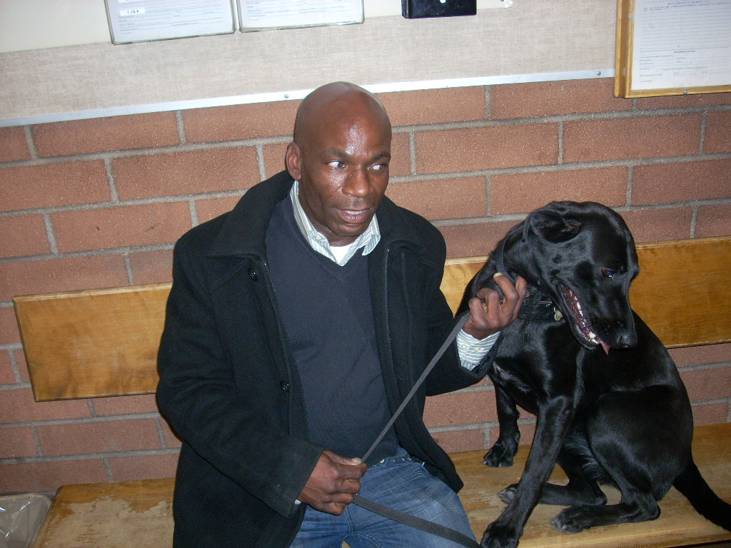

MEETINGS ATTENDED:

- 10-11-10 LASO Transit Tour
- 10-12-10 Property Owner security Meeting
- 10-14-10 BID Joint Security Committee
- 10-15-10 W Hotel/Metro Plaza Security Meeting
- 10-15-10 Kerry/Homeless Youth Meeting

- 10-19-10 LAPD Crime Control Meeting
- 10-20-10 LASO Hollywood Hills Sweep Meeting
- 10-22-10 Veteran’s Homeless Outreach Meeting
- 10-26-10 LAPD Crime Control Meeting
- 10-26-10 CPAB Meeting
- 10-29-10 Legal Council/Youth/BID Training
- 11-02-10 LA Film Institute Student Orientation
13) 11-02-10 LAPD Crime Control Meeting
14) 11-04-10 H+H Retail Meeting
15) 11-09-10 LAPD Crime Control Meeting
16) 11-09-10 Ecclesia church security meeting
17) 11-10-10 HCIT Meeting Chamber of Commerce
18) 11-12-10 LA Film School Student Orientation
19) 11-12-10 HHOT Outreach Team-BID Office
20) 11-15-10 Public Works Training Downtown LA
21) 11-17-10 HHYP Youth Homeless Presentation
22) 11-24-10 Greyhound Security Issues Meeting
23) 12-02-10 LA Film School Student Security Orientation

OUTREACH:

On 10-11-10, we received a radio call of a man down on the sidewalk in front of Pla Boy Liquors located at 6435 Yucca. We found James on the ground as he had fallen from his wheelchair. He seemed dehydrated. He said no one would help him get up so he was
forced to lie on the sidewalk. Our Officers bought him water from the liquor store and called PATH. Reggie and Crystal responded and took Mr. Parker into care.

On 10-20-10, our Officers contacted Michael at Sunset and Gordon. He is homeless and was in need of clothing. We got him a pair of pants and shoes from the Church of the Blessed Sacrament.

On 10-23-10, we found a homeless man named Ronald on the ground in the 1600 block of Orange. He had been drinking and had fallen. He was bleeding from a gash across his forehead and from his nose and ears. We called Paramedics who responded and took him to the hospital.

On 10-27-10, our Officers saw juvenile Gabriel limping along at 6776 Hollywood Blvd. They saw that he had no shirt or shoes. He had writing and drawings on his chest that appeared to have been drawn with a marker of some type. He was disorientated. He said that he had just arrived in Hollywood from Washington State.

Our Officers offered to help Gabriel and he agreed. I authorized our Officers to transport him to the Church of the Blessed Sacrament, but they were not able to help at that time. We then took him to My Friends Place where we released Gabriel to Pablo.

On 10-27-10, we received a radio call of a man down at the Check Cashing business located at 6401 Hollywood Blvd. Our Officers contacted Keith who said he felt dizzy
and very sick. He said that he is bi-polar and suicidal. We called Paramedics and RA27 responded and took Keith to the hospital for evaluation.

On 11-01-10, our Officers found a man on the ground at 1716 Cahuenga. He appeared to be under the influence of narcotics. We called LAPD Officer Gustafson who is an expert in this field. He determined that the man had ingested a combination of methamphetamine and heroin. Paramedics were called and they took the man to the hospital.

On 11-03-10, our Officers found 60 year old Emily sitting on the sidewalk in front of the Bank of America located at 6300 Sunset Blvd. They spoke to her and she seemed disorientated. She said she had been homeless for three days after being evicted from a board and care facility near Griffith Park. She said she had not eaten since yesterday except for a doughnut.

Emily perked up when she realized that our Officers intended to try and help her. We called on our friends at Get Love. John responded to the location with a bag lunch. He then arranged a two night stay at the Gilbert Hotel for Emily. He said this would give him time to seek additional assistance for Emily. We drove Emily to the Hotel.

On 11-04-10, we received a call from My Friends Place regarding a suicidal client named Michael. He had left a detailed note stating his intention to kill himself. We have a
troubled history with Michael. We arrested him on 07-09-10 for jumping on the back of one of our Officers as they were arresting a suspect who had been smoking marijuana.

Our teams began searching for Michael. He had just been released from the County Jail over the last weekend. Gary Holland, who was the Officer who was assaulted by Michael, located him at Ivar and Selma. He set up surveillance on Michael until we
could make arrangements for LAPD to respond. The effort was coordinated between MY Friends Place, the LAPD, and BID Security.

When LAPD arrived, we led them to Michael’s location. He was taken into custody without incident. He will be placed on a 5150 hold and will hopefully get the assistance that he clearly needs.

On 11-09-10, we got an update from John Ladner of Get Love. He had managed to locate Emily’s brother. He said that she had wandered away from her Board and Care where she has resided for the last twenty years. She suffers from a multiple personality disorder. John thanked us for our partnership and we thanked him for his help. We considered a group hug, but went back to work instead.

On 11-09-10, we found Tianna sitting on the sidewalk at 6200 Leland Way. She was hungry and disoriented. She was not able to communicate well, but have identification.

We drove her to the Church of the Blessed Sacrament where Yolanda interviewed her. Yolanda sent her to Sister Jennette who is a registered nurse. After her evaluation, the Sister told us that Tianna is supposed to be taking psychotropic drugs, but has not been taking them for some time.

The Sister was able to get Tianna a placement at the Exodus Recovery Mental Health and Urgent Care located at 1920 Marengo St. in Los Angeles. She gave Tianna a voucher for a cab ride to the facility. Our Officers waited for the cab. When it arrived the explained the situation to the driver and asked that he make sure Tianna would enter once they arrived. He said he was glad to help. Nice group effort.

On 11-26-10, our Officers contacted Rafael at 6765 Hollywood Blvd. He is homeless and in need of shelter. PATH was not available to respond, but they arranged for a bus to pick him up at 6TH St. and San Jullian so he could be transported to New Image located at 39TH and Broadway.

ENFORCEMENT:

In the Hollywood BID we have made a total of 823 arrests. Four hundred and fifty five were for drinking in public, 66 for urinating in public, 50 for misdemeanor drugs, 48 for trespass, 38 for illegal vending, 18 for battery, 35 for blocking the sidewalk, 20 for theft, 7 for vandalism, 32 for miscellaneous misdemeanors and 54 felonies. We also made 614 homeless referrals, assisted 809 agencies, provided extra patrol to 3199 locations, assisted 4270 citizens, handled 2578 radio calls for service and made 3295 business contacts.

In the Sunset BID, we have made a total of 265 arrests. One hundred and seventy one were for drinking in public, 22 for urinating in public, 17 for drugs, 14 for trespass, 2 for illegal vending, 4 battery, 8 for blocking the sidewalk, 1 for theft, 4 for vandalism, 9 for miscellaneous misdemeanors, and 13 for felonies. We also made 253 homeless referrals, assisted 314 agencies, provided extra patrol to 1098 locations, assisted 3058 citizens, handled 1064 radio calls for service, and made 976 business contacts.

The combined totals for both BIDS are 1088 arrests. Six hundred and twenty six for drinking in public, 88 for urinating in public, 67 for misdemeanor drugs, 62 for trespass, 40 for illegal vending, 22 for battery, 43 for blocking the sidewalk, 21 for theft, 11 for vandalism, 41 for miscellaneous misdemeanors and 67 for felonies. We also made a combined total of 867 homeless referrals, assisted 1123 agencies, provided extra patrol to 4297 locations, assisted 7328 citizens, handled 3642 radio calls for service, and made 4271 business contacts.

NOTED ARRESTS:
On 10-13-10, we received a radio call from the Chase Bank located at 6300 Sunset Blvd. regarding a woman attempting to cash a forged check. We learned that the crime had

indeed occurred and we arrested Lindora for Forgery, which is a felony. She was turned over to the LAPD.

On 10-14-10, we received a radio call of a trespass at the McDonalds located at 6776 Hollywood Blvd. An employee had received a shock upon opening the Custodian’s closet and finding Ernesto sleeping inside. We had warned Ernesto regarding trespassing
on several occasions and arrested him for that charge on 10-12-10. He was placed under arrest for the offense.

On 10-15-10, we received a radio call of a theft at the Gap store located on Hollywood Blvd. One of their loss prevention officers was chasing the suspect. We arrived in the area and arrested Charles for theft. After turning the suspect over to the LAPD, we learned that the suspect had a prior conviction for burglary, and as a result, served two years in prison. He was then charged with the felony charge of Petty theft with a prior conviction.

On 10-22-10, our Officers were on foot patrol near Hollywood and Whitley when they received information of a theft at the Trader Joes located at 1600 Vine. They walked to the scene and learned that a suspect took a large can of Sapporo beer without paying. When the security guard tried to stop the suspect he was shoved aside. The
suspect ran northbound. The use of force elevated this theft into a robbery which is a felony.

Our Officers began a search and found James hiding in an alcove several hundred feet north of the location. He matched the description of the suspect and had the can of beer. The guard was brought to the scene and he positively identified the suspect. We then placed James under arrest. He was booked by LAPD with a $50,000.00 bail.

On 11-02-10, we received a radio call of a woman causing a disturbance at 6711 Hollywood Blvd. Our Officers contacted Tour Guide salesman Patrick. He said that Tammy approached screaming at him and waving her arms. She then punched him twice, rapidly in the throat. Tammy then fled.

We have had numerous complaints about this severely mentally challenged woman. She has assaulted numerous people, but most refuse to make a private person’s arrest. Patrick said he did want to make an arrest. We found Tammy at 1721 Las Palmas and took her into custody. We were not able to communicate with her. She screamed at our Officers
until she was turned over to the LAPD. It was unknown if the Officers would end up booking her, or sending her to the hospital for evaluation.

Tammy is another example of a person that we invest an inordinate amount of time and resources on. She clearly is in need of intervention.

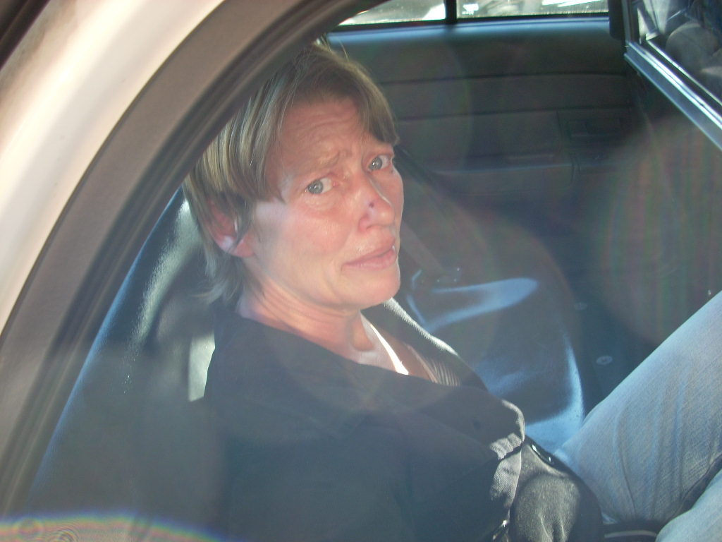

On 11-08-10, we received a radio call of a man causing a disturbance at the Greyhound Terminal located at 1715 Cahuenga. We spoke to Manager Lorena and learned that
Russell had been sleeping there. When asked to leave, he became irate and threatened her. She retreated into the lobby, but he followed. He pulled out his penis and exposed it to her as he continued making threats. He then left. We caught him
on Cahuenga south of Hollywood Blvd. and placed him under arrest for Indecent Exposure.

We have had some on-going issues at the Greyhound Terminal where 20 to forty people sleep each night. LAPD is also assisting us in this effort.

On 11-10-10, we received information from LAPD about a suspect named Sean. He was accused of stealing from a store just outside of the BID. A security guard tried to stop him. The suspect then nearly ran him down with his car. LAPD gave us the suspect and vehicle description and said he was wanted for Assault With a Deadly Weapon.

Later that morning, our Officers spotted the suspect driving through the BID. They followed discretely and called LAPD who responded with a helicopter, ten Patrol cars, and a couple of Detectives. They pulled the suspect over at Franklin and Cahuenga and took him into custody without incident.

On 11-12-10, we received a radio call of a theft at the 7-11 located at 1810 Cahuenga. A suspect stole a bag of Doritos and a hot chocolate, and then fled the scene. He has made many similar thefts in the past and has been warned to stay out of the store. Our Officers found Willie on Ivar. Victim Rubio was taken to the location and identified the suspect. He was then placed under arrest for theft. After turning him over to the LAPD, we learned that he had two outstanding warrants for $26,690.00. He also had three previous convictions for theft which elevated his charges to 666PC which is a felony.

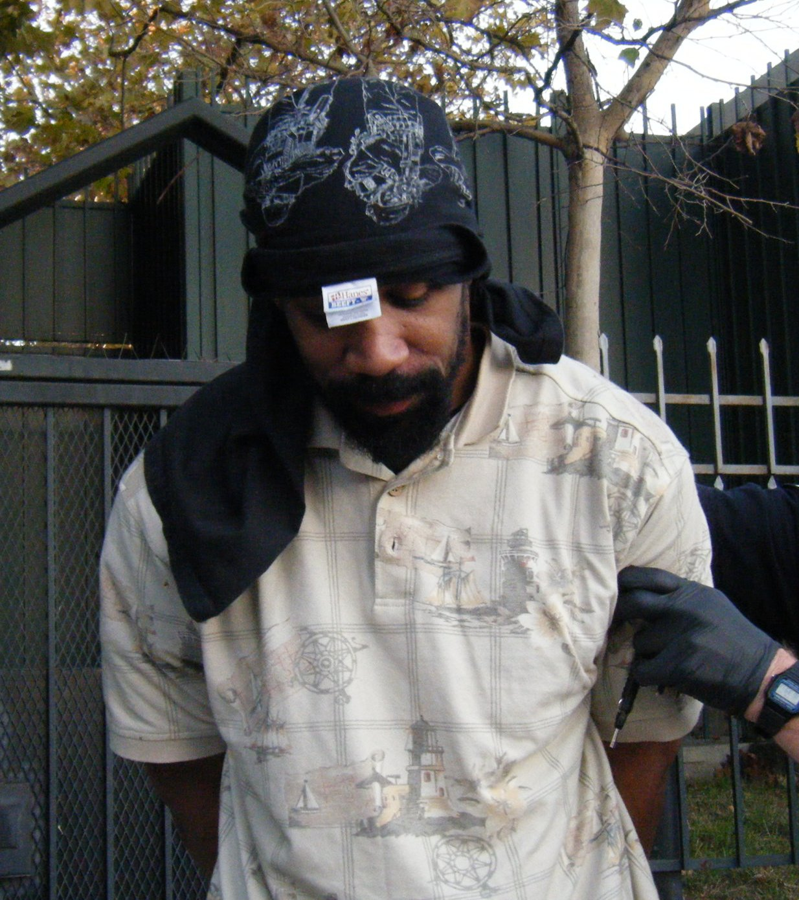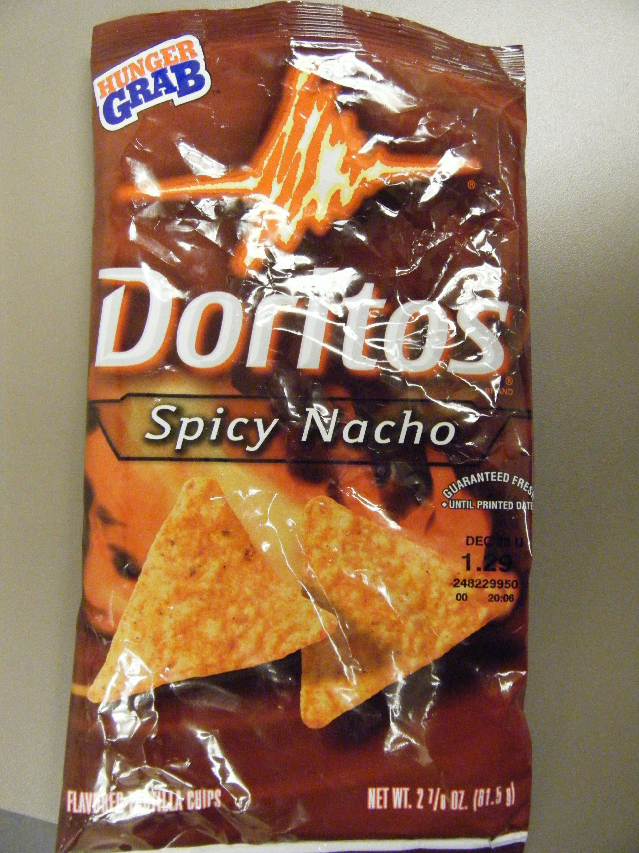

On 11-13-10, we received a call from security at 6801 Hollywood Blvd. A suspect tried to steal a Wolfgang Puck catering van. We arrested Nery for 10851 VC (Grand Theft Auto) as he tried to drive it out of the parking garage. We held the felony suspect until LAPD arrived.

On 11-15-10, we received a call from security at 6801 Hollywood Blvd. A woman was trespassing. When asked to leave, she pulled out a knife and threatened to kill several employees. She then left, still making threats. We caught up to Natalia in front of the location. She ran southbound through the traffic. We placed her under arrest and turned her over to LAPD who were on the scene within moments.

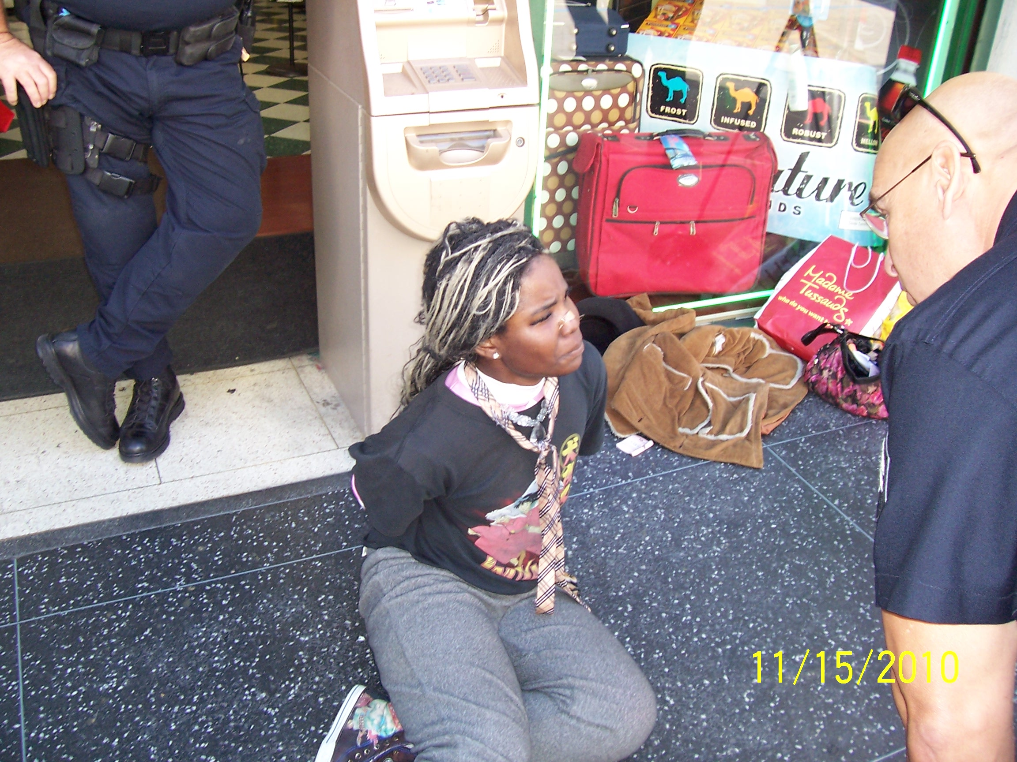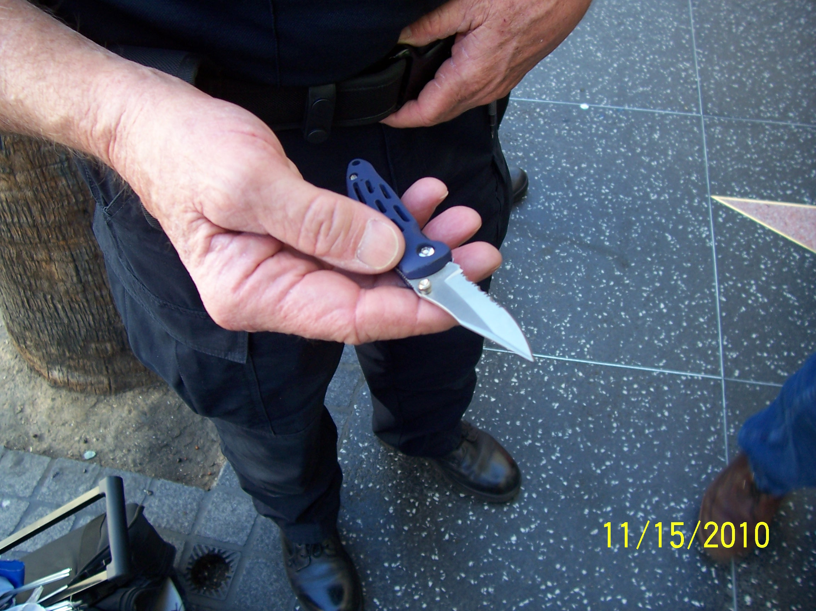

On 11-15-10, we received a call of a man attempting to cash a stolen check at the Bank of America located at 6300 Sunset Blvd. Upon arrival our Officers confirmed that the crime had been committed. LAPD responded and took custody of Shellion for the felony.

On 11-19-10, we received a call from Christopher. He said that a man at 6638 Selma was in possession of a computer that was stolen from his place of business. We responded and learned that the computer was indeed stolen. We arrested Michael for Grand Theft, which is a felony. He was turned over to the LAPD for booking.

DEPLOYMENT:

Our deployment for this period remained the same as past months. We currently work 6:00 A.M through 8:00 P.M. Monday through Saturday. On Sunday, we work 10:00 A.M. through 6:00 P.M.

TRAINING UPDATE:

During this period our officers received training in Sexual Harassment and Hostile Work Environment, Driver’s Training, Taser Usage, and Legal Update.

On 11-19-10, we had guest speaker Eddie Zebo provide training for our Officers. He is a Paramedic with the Los Angeles County. He instructed us on how to handle gunshot, stabbing, and other serious wounds if one of our Officers were to fall victim. He also provided us with gauze, tape, scissors, etc, which we will carry in each of our vehicles.

