Stephen Seyler
BID Executive Security Director

SUMMARY FOR 2-7-11 THROUGH 3-6-11
During this period, we continued following our model for improving the quality of life in the BID areas. We use a combination of strict enforcement of the law with outreach to the business, tourist, citizen, and homeless communities. We act as ambassadors for Hollywood and consider ourselves to be problem solvers and members of this community. One illustration was our participation in the Police Athletic League Fundraiser held last Sunday. Our company is a sponsor, and members of our team were in attendance.

EVENTS OF INTEREST:
On 02-12-11, we received a radio call from the W Hotel located at 6250 Hollywood Blvd. Three people were stuck inside the Metro Line elevator. Our Officers calmed the people and assured them that help was on the way. Mechanic Jose arrived a short time later and freed the grateful trio who thanked our Officers for their rapid response.

On 02-12-11, we received a radio call of a CD vender assaulting a man at 6801 Hollywood Blvd. The suspect had fled the scene. We brought Victor to our office and got a statement from him. We then drove him and a witness to the LAPD Hollywood Station so that he could make a crime report. We then drove them back to the Metro Station so they could go home.

Also on 02-12-11, a man named Isaac Yuno came to our office complaining of being harassed by CD venders. He is a resident and is constantly bothered by very aggressive CD sellers. He gave us a signed statement outlining his concerns.

During our patrol duties, we often deal with the mentally ill and those suffering from substance abuse. We also meet a wide variety of people who seem to be marching to the beat of a different drummer. Hollywood has proven to be a magnet for strange characters. On 2-23-11, our Officers stopped to investigate what appeared to be some kind of shell game. On closer examination, they met what they termed as being “The Biggest Nut in Hollywood”.

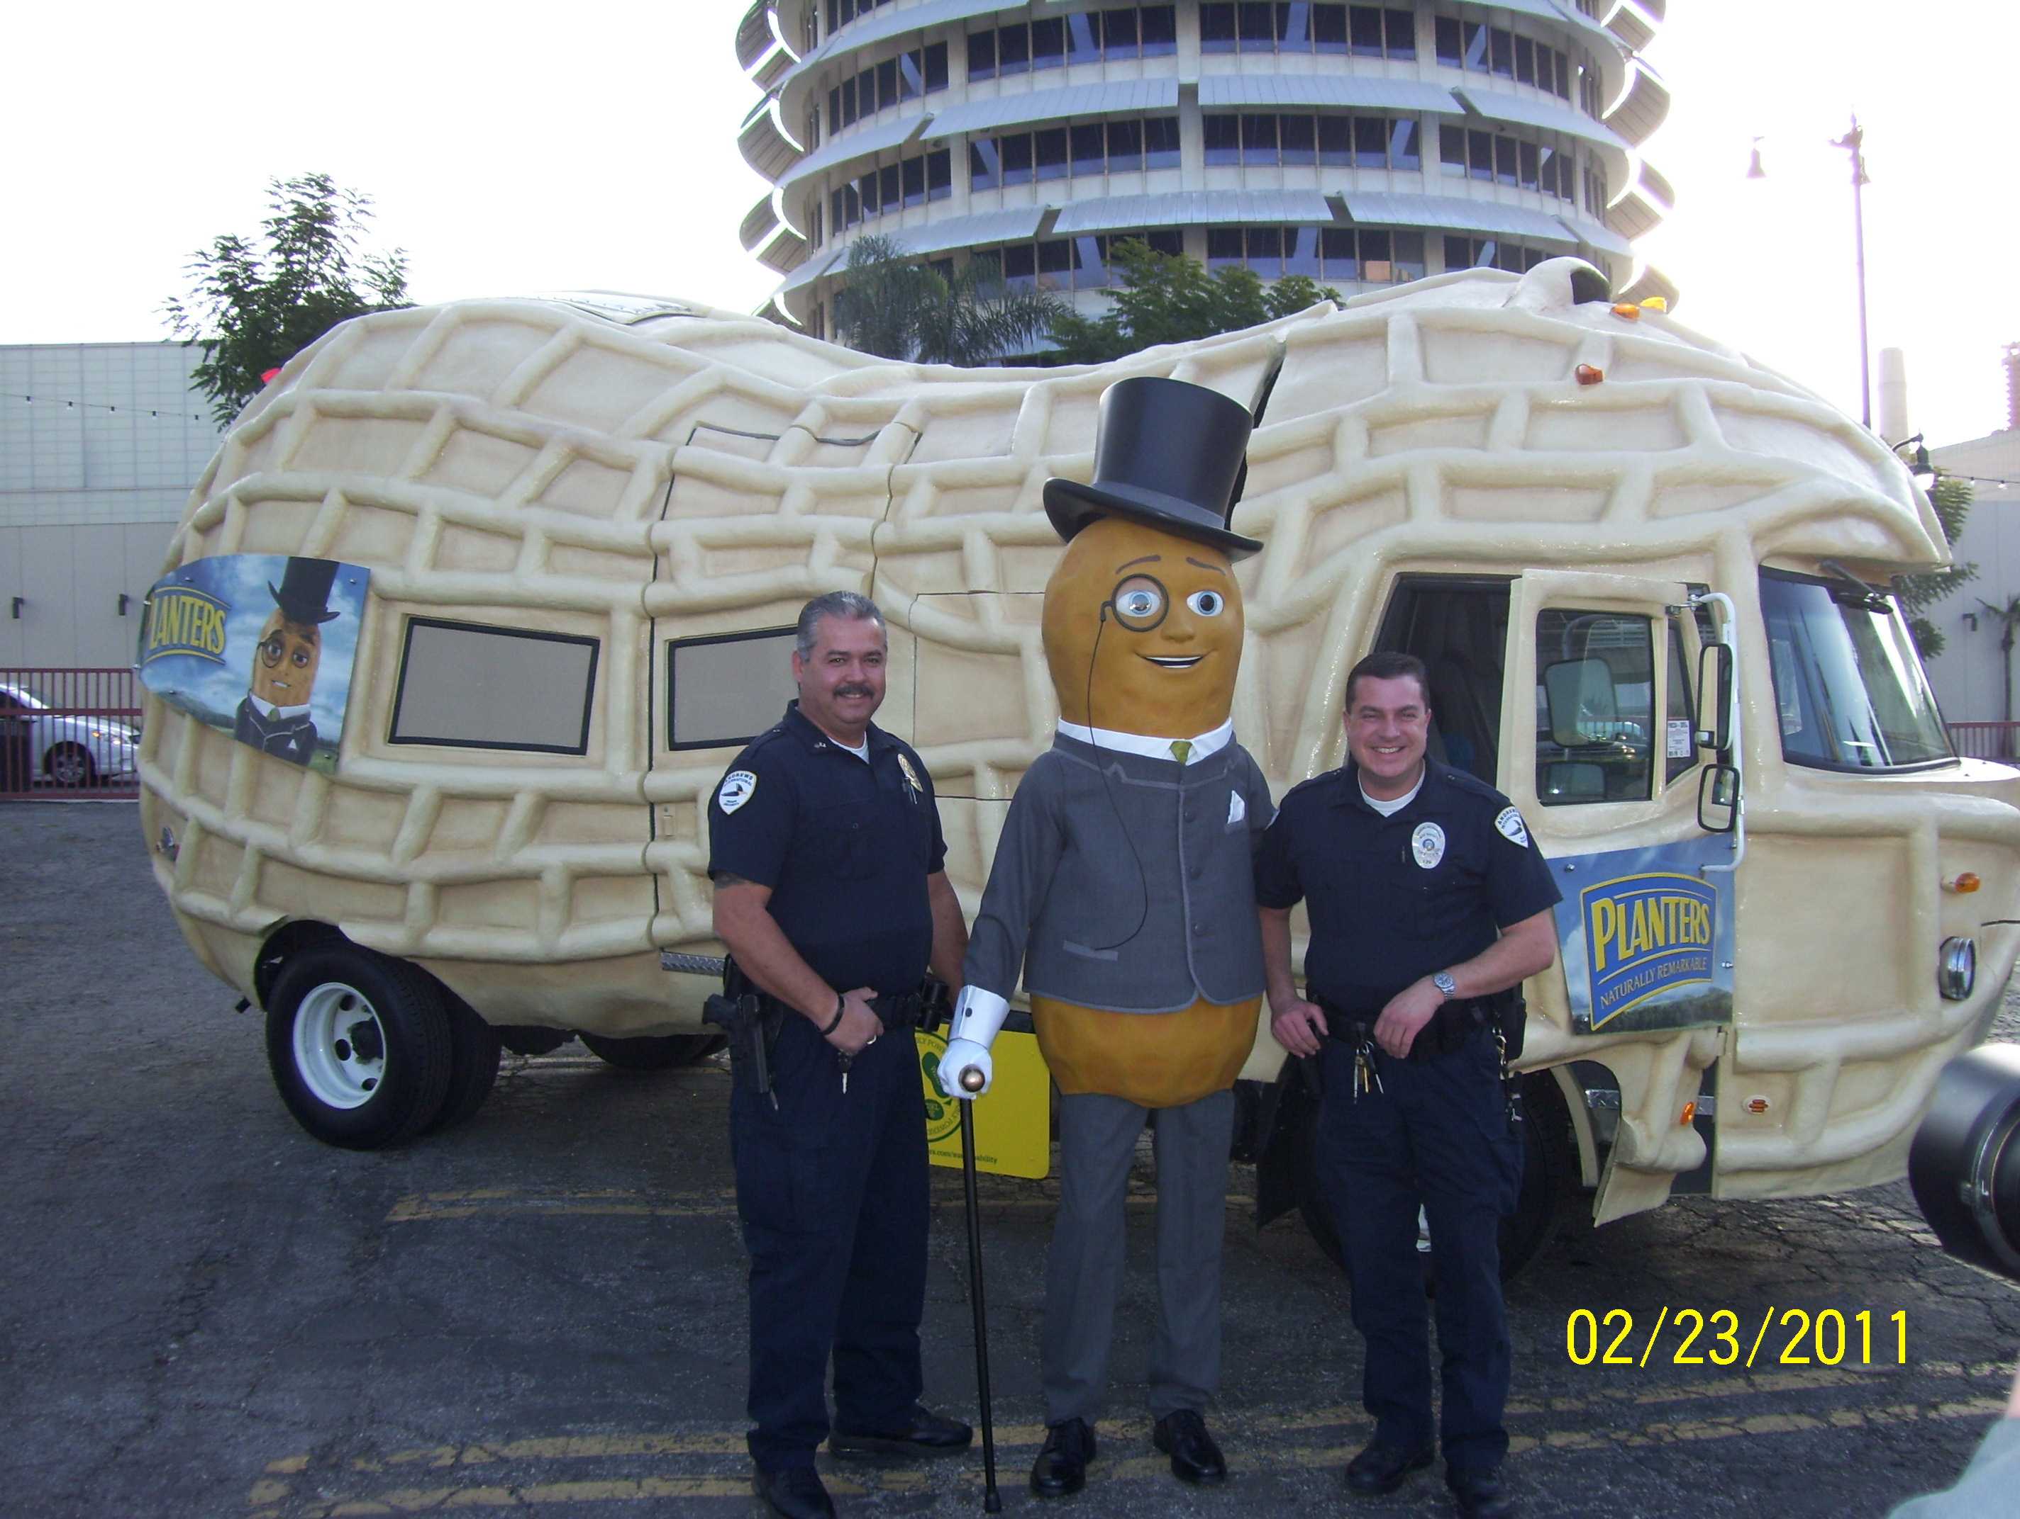

Problem Solving
On 02-17-11, we received a radio call of a man causing a disturbance at Hollywood and Orange. It turned out to be a very angry homeless man named Serge (AKA No hands). He had spilled his bag of M+M’s on the sidewalk and could not pick them up. Our officers contacted a nearby businessman and he donated a fresh bag of M+M’s just to get Serge to leave. The plan worked and a happier Serge was on his way. Problem solved. At least for the moment.

On 2-18-11, we contacted Arthur as he was sleeping on the sidewalk. He said he was homeless. We noticed that he had a court ordered bracelet on his ankle and he admitted that he was a sex offender. We contacted LAPD Detective Smith who told Arthur to register in Hollywood ASAP.

On 2-24-11, we did a walk-through of the vacant property located at 6759 Selma. We have made numerous arrests for trespass in the last few weeks. The owners respond to board up the property, but the suspects continue to break in. We have recovered drug paraphernalia and stolen property at the location. We are concerned that if left unattended, this location will become a hub of criminal activity. During the walk-through, we recovered about seventy syringes. We took them to the Saban Free Clinic for disposal.

On 3-2-11, we received a radio call of a man screaming at pedestrians and running into traffic at Hollywood and Highland. We contacted Harold and calmed him down. He started crying and said he was having a mid life crisis. We were able to convince him to
have his crisis at home. We then walked him to the Metro Station and he departed Hollywood.

On 3-6-11, Bill Farrar and I attended the PAL Fundraiser held at the Lucky Strike Bowling Alley along with our wives. Andrews International was one of the sponsors.

MEETINGS ATTENDED:

- 2-8-11 LAPD Crime Control Meeting
- 2-9-11 Community Impact Meeting- Chamber
- 2-10-11 BID Joint Security Meeting
- 2-10-11 Street Character Issues-Taft Building
- 2-10-11 Chamber of Commerce luncheon
- 2-14-11 HHOT Outreach Meeting-BID Office
- 2-15-11 LAPD Crime Control Meeting
- 2-17-11 HBID Board Meeting-Yearly Report
- 2-17-11 H+H Retail Meeting
- 2-18-11 BID Planning Meeting
- 3-1-11 LAPD Crime Control Meeting
- 3-3-11 H+H Retail Meeting
- 3-6-11 PAL Fundraiser

OUTREACH:
On 02-09-11, we received a radio call of a shoplifter at the Iguana Clothing Store located at 6320 Hollywood Blvd. Upon arrival we contacted the suspect who was 14 year old Christy. We then learned that Christy was a runaway from East Los Angeles. We turned her over to the LAPD.

On 02-10-11, our Officers contacted Dwayne in front of 6384 Hollywood Blvd. He seemed to be under the influence and in need of help. We gave him information about PATH and other services that might be of use to him. He drifted off to sleep as our officers were talking. We were unable to rouse him and called the LAPD and Paramedics. RA 52 responded and took Dwayne to the hospital for a possible heroin overdose.

On 2-14-11, our officers met Jose at 1680 Vine street. He had just arrived from Fresno and had nowhere to stay. He said he needed work and shelter. He was directed to the Work Source at the Taft Building as well as other services. We then called Jorge from PATH who was able to place Jose into a temporary shelter.

On 02-16-11, our Officers saw Joan sitting on a bus bench in the rain at 6300 Hollywood Blvd. They asked if she would like a dry place to sleep, at least until the rain stopped. She said “No thank you. I have my apartment down the street.” We know Joan to be homeless. We will continue to try to build a rapport with her.

On 2-17-11, our officers helped homeless Veteran Norman fill out necessary paperwork for a Veteran’s Administration placement. Gett Love is boarding him at the Gilbert Hotel until all the paperwork is processed.

We spoke of John in a past report. He had been homeless and unemployed. We recommended John to our company and Andrews International agreed to hire him. On 2-23-11, we spotted John at his new security job on Hollywood Blvd. We think we gained a great, new employee.

On 3-4-11, our officers met with homeless Veteran Mr. Breed. He thanked them for helping him fill out various paperwork needed to be eligible for housing through the Veteran’s Administration. He said his paperwork has gone through and he is now eligible. He has an appointment next week.

On 3-5-11, we received a radio call of a woman destroying merchandise and throwing glass bottles at the employees at 7021 Hollywood Blvd. Our Officers tried to calm the woman who was named Jean. They soon realized that she was homeless, had mental illness issues and was not on her medication. We stayed with her in order to keep her from harming herself or others until Paramedics arrived and took her to the hospital for evaluation.

On 3-5-11, we received a radio call of a man down at the Jack in the Box located at 6407 Sunset Blvd. Upon arrival we found a man unconscious, but breathing. We called Paramedics and Unit 82 responded and took him to the hospital.

On 3-6-11, we met Josh and Robert. They were trying to raise funds to get to Las Vegas. We referred them to the Church of the Blessed Sacrament for Traveler’s Aid.

ENFORCEMENT:
In the Hollywood BID we have made a total of 179 arrests. Eighty five were for drinking in public, 19 for urinating in public, 32 for trespass, 11 for illegal vending, 3 for battery, 10 for blocking the sidewalk, 3 for theft, 1 for vandalism, 8 for miscellaneous misdemeanors, and 7 for felonies. We also made 110 homeless referrals, assisted 57 agencies, provided extra patrol to 348 locations, assisted 1259 citizens, handled 422 radio calls for service and made 546 business contacts.

In the Sunset BID, we have made a total of 43 arrests. Fifteen were for drinking in public, 7 for urinating in public, 7 for trespass, 2 for battery, 5 for blocking the sidewalk, 4 for theft, 1for miscellaneous misdemeanors, and 2 for felonies. We also made 42 homeless referrals, assisted 18 agencies, provided extra patrol to 213 locations, assisted 1017 citizens, handled 225 radio calls for service, and made 382 business contacts.

The combined totals for both BIDS are 222 arrests. One hundred for drinking in public, 26 for urinating in public, 39for trespass, 11 for illegal vending, 5 for battery, 15 for blocking the sidewalk, 7 for theft, 1 for vandalism, 9 for miscellaneous misdemeanors and 9 for felonies. We also made a combined total of 152 homeless referrals, assisted 75 agencies, provided extra patrol to 561 locations, assisted 2276 citizens, handled 647 radio calls for service, and made 928 business contacts.

NOTED ARRESTS:
On 02-09-11, we received a radio call of a disturbance at the Stout restaurant located at 1544 Cahuenga. We spoke to Shawn who said he was eating at an outdoor table when a man approached and stuck a Styrofoam cup in his face asking for money. When he refused the man became belligerent, shouting profanities. The Manager then asked the man to leave.

The man walked away, but then returned quickly, still shouting profanities. He spit in the victim’s face and then left walking southbound on Cahuenga. A customer followed him to the Jack in the Box located at 6407 Sunset Blvd. We responded and got a Private Person’s Arrest form signed by Shawn. We then arrested Terry for Battery. He was turned over to the LAPD. The Manager (Libitola) said that Terry is a chronic problem as he begs for money and then shouts profanities if people decline to give it to him.

We arrested this suspect again on 2-17-11 as he returned to the location and spit on the Manager.

On 02-11-11, our Officers stopped to talk to Alberto and Alfonso as they were sitting on and blocking the sidewalk at 6724 Hollywood Blvd. As our Officers approached the two, each dropped and tried to conceal handguns. We were able to flag down a passing LAPD unit who assisted us. The guns turned out to be very realistic replicas. The LAPD Officers took custody of the two for further investigation. The suspect named Alfonso also had an outstanding misdemeanor warrant.

On 2-15-11, our Officers were flagged down by employees of the management company for a vacant building located at 6767 Selma. We have made numerous trespass arrests at the location in the past. The property has been boarded up several times, but homeless people keep breaking in. On this occasion, we were told that the employees found a man sleeping in a closet and they wanted him arrested for trespass.

Our Officers told Yitzchakbaer that he was being placed under arrest. He said that he would not submit. He then tried to pull away as the Officers grabbed his arms. He lunged forward and struck his head on the wall causing a small cut. He was taken into custody without further incident.

On 2-18-11, our Officers were flagged down by two scientology Guards at 6331 Hollywood Blvd. They had stopped two suspects from writing some graffiti and then were assaulted by them. One suspect (Kevin) ran from the guards and towards BID Officer Gordon. He struck Gordon with his elbow as he passed him. Suspect Benjamin also ran, but both suspects were eventually caught by our back-up teams.

Both were arrested for assault. One resisted, but we were able to take him into custody without injuring him. Officer Gordon was experiencing pain to his chest and we sent him to Kaiser as a precaution. He was given pain medication and allowed to return to duty.

On 2-22-11, we arrested long time problem homeless youth Kevin and his girlfriend Sara as they were trespassing in the vacant building located at 6759 Selma Ave. Kevin initially ran from the Officers, but returned as they arrested Sara. Kevin then threatened to attack the Officers. As he approached, Sgt. Patton removed his Taser from his holster. Kevin then submitted to the arrest, but threatened that he would ‘Get’ our Officers.

Officers Sterling and Holland transported the suspects to the LAPD Station. As they walked through the door, Kevin tried to pull away and flee. The Officers were able to control him with the help of LAPD Officer Sanchez. The LAPD Watch Commander interviewed Kevin who told him that Officer Sterling had punched him on the nose several times at the doorway.

Sgt. Patton then drove to the scene to investigate the charges. Kevin then alleged that Patton had also struck him in the face. Note that Patton was not even at the location
when the incident occurred. Officer Sanchez told the Watch Commander that no punches were thrown during the incident. It seems clear that the allegations were Kevin’s attempt

to ‘Get’ our Officers. We then learned that Kevin had $45,000.00 in outstanding warrants. Sara had $22,000.00 in warrants.

On 2-23-11, we arrested Billy for Tampering with a Parking Meter at 1500 Argyle. After transporting him to the LAPD Station, we learned that he had two outstanding Felony No Bail Warrants.

On 03-02-11, we received a radio call to assist Gap Security at 6933 Hollywood Blvd. We arrested Christopher for theft. His charge was changed to burglary which is a felony after it was determined that he had entered the store with the intent to steal.

On 3-3-11, we arrested Robert and Christopher for drinking in public at 6777 Hollywood Blvd. After turning them over to the LAPD, we learned that Christopher was a registered sex offender.

On 3-3-11, we received a call from Andrews International V/P Bill Farrar regarding a man with a Samurai sword at the Starbucks located at 6801 Hollywood Blvd. Our Officers responded and assisted Bill with the arrest of a man named Howard.

On 3-4-11, we arrested Jeffery for drinking in public at 1600 N. Wilcox. We then learned that he had an outstanding No Bail Felony Fugitive Warrant.

DEPLOYMENT:
Our deployment for this period remained 6:00 A.M. to 8:00 P.M. Monday through Saturday and 10:00 A.M to 6:00 P.M. on Sunday. We did adjust our hours on a couple of occasions in order to stay later to enforce illegal vending laws.

TRAINING UPDATE:
During this period, our officers received training in legal update, sexual harassment and hostile work environment, driver training, shooting and use of the Taser.

