Stephen Seyler
BID Executive Security Director
Joint BID Security Summary

SUMMARY FOR 9-9-13 THROUGH 10-6-13
This report takes us through week 40 of the year. When comparing our activities with this time last year, we see that we have made 225 less arrests although we have made an additional 3 felony arrests. Radio calls are above last year’s record breaking pace by 504. We have also added an additional 6540 citizen contacts over last year’s total. Our business contacts have also increased by 5120 this year.

I believe that our arrest totals are down due to the 3 month trial of later night patrol that we did earlier in the year. Our increase in radio calls for service matches our established pattern. This number increases yearly as more people learn of our services. The increase in citizen and business contacts can be attributed to the addition of our high visibility unarmed Public Safety Officers. They walk and ride T-3’s on the Blvd. each day acting as eyes and ears for our Officers and Ambassadors for Hollywood. They also help with our outreach to the homeless. We have also increased foot and bicycle patrols by our armed Officers.

EVENTS OF INTEREST:
On 9-12-13, I attended the annual PAL Fundraiser. Bill Farrar, Mike Harkins, Joe Salazar, Randy Andrews and a gaggle of company V/P’s attended the event. Kerry Morrison was one of the honorees and she gave a moving acceptance speech. The crowd rose for a standing ovation as she took the stage and again after she finished her speech.
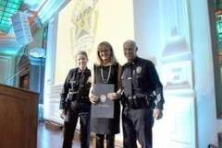
Kerry with new LAPD Captain Zarcone
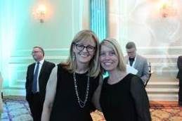
The Lovely Ladies of the BID

The theme for costumes this year was to dress as your hero. This turned out to be a lame theme and few people came in costume. Joe Mariani and six other guys went all out by putting on a pair of glasses and then claiming to be Clark Kent. The costumes were so underwhelming this year that I think they even canceled the best costume prize. We were forced to go to the archives to show a prize winning costume from a past event.
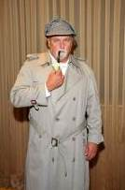
Don’t Mess With the Law

On 9-14-13, our Officers saw a hit and run accident at 6340 Lexington. They followed the suspect, Sonia. She saw the Officers in her rear view mirror and decided to pull over. Our Officers stayed with her until the LAPD arrived and took over the investigation.

On 9-26-13, our Officers were conducting an extra patrol of the parking structure located at 7021 Hollywood Blvd. (Galaxy). They saw a suspicious vehicle and the guard said it had been there for some time. We contacted the LAPD who ran the plate. We then learned that it was a stolen vehicle out of Santa Monica. The LAPD responded and recovered the vehicle.

On 10-1-13, I attended the LAPD Crime Control Meeting. A Detective gave me some information about a strong armed robbery that had occurred recently. He asked if we could help locate a suspect that he described as being a male white with a Mohawk. Our Officers had noticed a new man in town who matched this description.

The next day Officers Mike and Mike spotted this man at the Starbucks located at Hollywood and Vine. They called LAPD Officers who responded to the scene. The man was taken into custody. The LAPD Officers then contacted the victim in the case. After interviewing him, they reclassified the incident as being a business dispute rather than a robbery. Even though it turned out that this was not a felony after all, it is still a good illustration of our great working relationship with the LAPD.
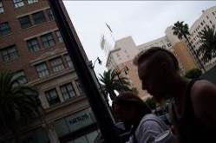
Robbery Suspect

During this week, we received a call of found property at the parking lot located at 1618 Las Palmas. It turned out to be a fully loaded revolver. We stood by until the LAPD arrived to take the roscoe.
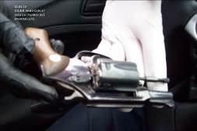

On the early morning of 10-2-13, we found a man in a cage at 6801 Hollywood Blvd. He was later joined by a second man that apparently broke into the cell. He said they had counterparts doing the same on Times Square. Perhaps our BID staff can check on this during their New York City trip this week.
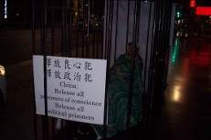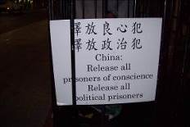

MEETINGS ATTENDED:

- 9-10-13 LAPD Crime Control Meeting
- 9-10-13 HHOT Outreach Meeting
- 9-10-13 SBID Board Meeting
- 9-12-13 PAL Fundraising Benefit
- 9-12-13 BID Joint Security Meeting
- 9-17-13 LAPD Crime Control Meeting

- 9-19-13 HBID Board Meeting
- 9-23-13 Hollywood 4WRD Outreach Meeting
- 9-24-13 HHOT Outreach Meeting
- 9-24-13 LAPD Crime Control Meeting
- 9-26-13 Community Impact Meeting
- 10-1-13 LAPD Crime Control Meeting
- 10-3-13 Richard McFarthing Outreach Meeting

OUTREACH:
On 9-9-13, Sgt. Patton and Officer Sterling were contacted by a man at the 7-11 store located at 1810 Cahuenga. He asked for coffee and said he was hungry. The Officers bought him coffee and a candy bar in a rapport building effort and then gave him information about services available at the Church of the Blessed Sacrament.

On 9-15-13, we found a man down at 1501 Sunset Blvd. The man was non-responsive so we called Paramedics. They responded and treated the man at the scene.

On 9-15-13, we assisted LAPD Senior Lead Officer Irv Isabella in the 1400 block of Highland. Irv was attempting to have a 5150 hold placed on Roxanne. Sgt. Reyes and Officers Anderson, Kanagi, Gordon and Lopez responded. We brought our pick-up truck and transported Roxanne’s huge amount of property for the LAPD so they could store it. A 5150 hold was placed and the long term plan is to seek a conservatorship for her.

Our Officers also got brooms and helped clean up the area of Roxanne’s encampment. We will hope for the best for Roxanne as we await developments.

On 9-16-13, we received a call of a man talking to himself at Hollywood Toyota located at 6000 Hollywood Blvd. Upon arrival our Officers Mike and Mike contacted Pat who pointed out the man. He said the man had not done anything wrong, but that they were concerned for him.

Our Officers recognized that man as being Michael. He had been a homeless man and a great victory for the homeless outreach community. He is now housed in a Gett Love facility named in his honor. He had been at Gett Love and was walking back to Michael’s Village. He said he felt light headed due to the heat. The Officers requested permission to take Michael home and this was granted.
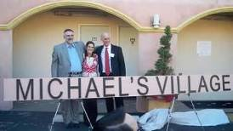
Michael on the left

On 9-17-13, we received a call of a disturbance at the Saban Free Clinic located at 6043 Hollywood Blvd. Dr. Babak Etteical was engaged in a conversation with 31 year old patient Jamie. The Dr. told us that Jamie had been demanding drugs and that she threatened to stab him and staff members if she did not get them. She also threatened suicide.

Our Officers Watkins and Sewell walked Jamie outside and spoke to her. She assured them that she would not stab anyone as she currently did not have a knife. She then dumped the contents of her purse onto the sidewalk in order to prove the point. She screamed, wailed and sobbed. She was distraught and said she needed her drugs.

We called the LAPD and Unit 6A77 (Dominguez/Guitierrez) arrived and placed a 5150 hold on Jamie. Dr. Etteical thanked everyone involved. He was frustrated that he couldn’t have done more to assist Jamie.

On 9-17-13, our Officers spoke to the homeless Mike. He was badly in need of clothing. Mike and Mike went to the BSSSC and Spencer allowed them to select new clothing for Mike. They then took the clothes to him. They also told him that he could go to the church for a shower after 1:00 P.M.

On 9-17-13, our Officers contacted Kenneth. He is in poor shape and struggling with alcoholism. We called Mark from Step up on Second and he responded to the location and re-opened Kenneth’s case. On 9-18-13, we met with PATH and they were able to place Kenneth into a shelter.
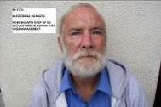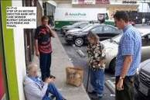
Step up Contacting Kenneth

On 9-24-13, our Officers contacted the homeless Dan at 6450 Sunset Blvd. We contacted Reggie from PATH who agreed to interview him regarding entering a shelter. As he had no transportation, we drove Dan to the PATH facility.
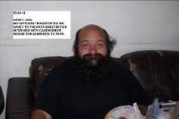
Homeless Dan

On 9-26-13, our Officers Mike and Mike again contacted Mike. They contacted Reggie from PATH regarding shelter for Mike, but there were no beds available. They then spoke to Michelle from Step up on Second. She needed Mike to fill out some paperwork so that he could get services. Our guys transported Mike to the Step up office as he had a sprained ankle.
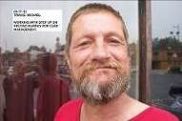
Mike
On 9-26-13, we received a call from Courtney of PATH. She said that she had a bed available for Destiny and was hoping that we could find her. We did locate Destiny at 6301 Sunset Blvd. and she was very excited by the news. We called Savannah and she said she would come to pick up Destiny at MFP ASAP.

Destiny is a 19 year old homeless woman who told us that she came here from Big Bay Maryland. We believe that she is a methamphetamines user and as a result seems paranoid and confused at times.
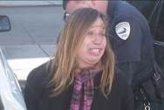
Destiny Photo from 12-21-12 Arrest
On 10-4-13, our Officers Gordon and Gonzales saw Carlos drinking a beer at 1122 Vine. They arrested him and took him to the LAPD Station where he was cited out. Carlos said that he was homeless, but was told that he would be arrested if he tried to access services because he was a former gang member. Our Officers assured him this was not the case and they gave him information regarding available services.
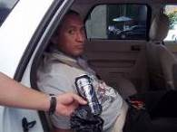
Carlos

On 10-2-13, we received a call of a woman screaming at the Jo Jo Market located at 1356 Vine. After contacting Anna. Officers Islas and Jacquez learned that she was screaming

because she was distraught as someone had broken her transistor radio. The Officers walked over to the Dollar Value Store and bought her another one. Woe turned to joy as she got a new toy!

ENFORCEMENT:
In the Hollywood BID we have made a total of 604 arrests. Three hundred and forty seven were for drinking in public, 45 for urinating in public, 57 for trespass, 10 for illegal vending, 13 for battery, 62 for blocking the sidewalk, 10 for theft, 13 for miscellaneous misdemeanors, and 47 for felonies. We also made 436 homeless referrals, assisted 138 agencies, provided 1155 foot beat patrols for a total of 1443.1 hours, assisted 12312 citizens, handled 2584 radio calls for service and made 5991 business contacts.

In the Sunset BID, we have made a total of 243 arrests. One hundred and seventy two were for drinking in public, 21 for urinating in public, 15 for trespass, 6 for battery, 13 for blocking the sidewalk, 3 for theft, 4 for miscellaneous misdemeanors, and 9 for felonies. We also made 238 homeless referrals, assisted 113 agencies, provided 89 foot beat patrols for a total of 64.5 hours, assisted 4095 citizens, handled 1285 radio calls for service, and made 2511 business contacts.

The combined arrest totals for both BIDS are 847 arrests. Five hundred and nineteen for drinking in public, 66 for urinating in public, 72 for trespass, 10 for illegal vending, 19 for battery, 75 for blocking the sidewalk,13 for theft, 17 for miscellaneous misdemeanors and 56 for felonies. We also made a combined total of 674 homeless referrals, assisted 251 agencies, provided 1244 foot beat patrols for a total of 1507.6 hours, assisted 16406 citizens, handled 3869 radio calls for service, and made 8502 business contacts.

NOTED ARRESTS:
On 9-9-13, our Bike Team Officers Ramirez and Trujillo arrested Christopher for drinking in public in the 6600 block of Yucca. After taking him to the LAPD Station they learned that he had a Felony No Bail Warrant out of San Bernardino County.

On 9-17-13, our Officers saw Charles standing in the middle of Hollywood Blvd. He had a beverage in one hand and his exposed penis in the other. He boldly urinated on the sidewalk as tourists and others tried to avoid the disgusting display. When asked why he did this, he simply replied that he had not done it. We gave him a free ride to the LAPD Station.
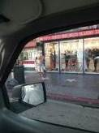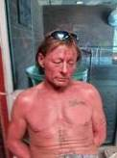
Bold Urinator Charles

On 9-20-13, our Officers saw 59 year old Bradley spray painting on some steps and on the sidewalk at 1440 Vine Street. He was transported to the LAPD Station where he was cited out. Bradley is a little older than our usual tagging suspect.
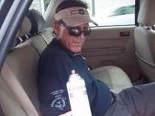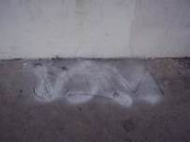
Bradley the Aging Tagger

On 9-28-13, our officers saw Ryan and Daniel at 6443 Hollywood Blvd. They were posting handbills on private property. They were arrested for 24.03 LAMC. They had a van full of handbills and were really making a mess. LAPD responded and cited them out.
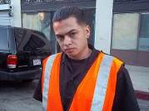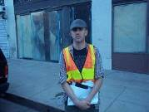

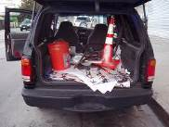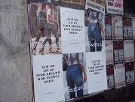
Brothers Ryan and Daniel

On 9-28-13, Officers Coogle and Sterling woke Phillip who was sleeping on the sidewalk at 6505 Hollywood Blvd. He refused to get up and shouted profanities and threats at the Officers. He approached Coogle and put his finger very close to his face saying “I’m this close to kicking your F__ing ass”. He then slapped Coogle in the face. A struggle ensued as the Officers attempted to arrest Phillip. He elbowed Sterling and fought the Officers. He then put his hand on Coogle’s gun and said “I’m gonna shoot you F__ing security guards with your own gun”. Coogle was able to hold onto his weapon while he pepper sprayed Phillip.

Phillip ran into traffic. Our Officers pursued and called for back-up. They caught up to him on Hollywood Blvd. and the fight was on. Officers Kanagi and Gordon were kicked. Sgt. Harkins arrived and the Officers were able to guide Phillip to the ground and handcuff him.

The LAPD and Paramedics arrived. Scott told them that he needed his psych medications. He said he had run out. He was taken to the hospital. The LAPD charged him with Battery and the felony 664 487(a) (2) PC (Grand Theft of a Gun).
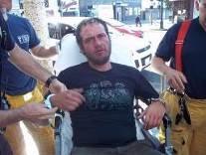
Phillip

We have been receiving a large number of calls regarding John. Many businesses complain about his aggressive and disruptive behavior. On 9-30-13, our Officers were flagged down by Steven Whiddon who is a Field Deputy for Councilman Mitch O’Farrell. John was ‘in his face’. We arrested John for blocking the sidewalk. We arrested him for drinking on 5-22-13, 6-5-13 and 6-13-13. We will document our contacts with John in hopes of obtaining a stay away order.
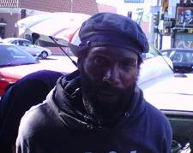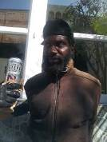
John from Two Recent Arrests

On 10-1-13, Our Officers saw Kyle in front of the McDonalds located at 6776 Hollywood Blvd. He was using a chisel to remove the grout in an apparent attempt to remove a part of the Walk of Fame. He was arrested for Felony Vandalism.

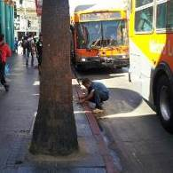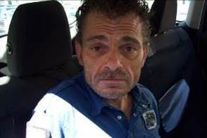

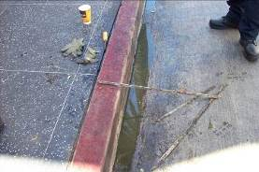
Kyle’s Illegal Renovation of the Sidewalk

On 10-5-13, we received a call of a theft suspect at the CVS Pharmacy located at 1747 Cahuenga. We arrested Aaron. We then learned that he had a prior conviction for this offense and his charge was elevated to the felony of 666PC.
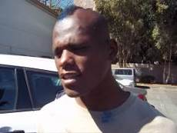
Felon Aaron

DEPLOYMENT:
During this period, we worked from 6:00 A.M. to 8:00 P.M on Monday through Saturday. On Sunday we worked from 10:00 A.M. until 6:00 P.M. On 10-4-13 we started another late night patrol experiment. We put three two Officer unarmed teams on Hollywood Blvd. from 9:00 P.M. until 3:00 A.M. They are supported by two armed Officers in a vehicle. Their mission is to observe and report suspicious and unlawful activity to the LAPD. This is a 14 week trial. The first weekend went very well with great communication between BID Security and the LAPD.

TRAINING UPDATE:
During this period our Officers received training on the FATS machine at our range in Burbank, Legal Update, Sexual Harassment and Driver’s Training. We also provided bicycle training to another Officer to add to our growing team.

