Stephen Seyler
BID Executive Security Director
Joint HBID/SBID Report

SUMMARY FOR 11-11-13 THROUGH 12-8-13
This report takes us through week 49 of this year and obviously this will be our last monthly report of the year. We have a clear picture of the trends for this year. Arrests are down by 190 compared to this time last year although we have made 14 additional felony arrests. We believe the lower arrest totals can largely be attributed to our late night patrol experiment from early in the year. We extended our hours from 2-1-13 through 4-29-13 without any addition in manpower. This diluted our manpower and resulted in some loss in productivity.

Our radio calls for service are up by 535 over last year’s record pace. Citizen contacts are up by 8144 and Business contacts are up by 7087. We attribute these increases to our clients request that we provide more highly visible patrol this year. To this end we are now deploying unarmed Public Safety Officers who walk the HBID on a daily basis. They also patrol on T-3’s. We also have an armed Bike Patrol that is out at least 5 days a week. They patrol both BID’s.

Our other armed Officers are also walking foot patrols when time allows. The constant increase in calls for service has somewhat limited this, but we have been able to increase these patrols dramatically over previous years totals.

EVENTS OF INTEREST:
On 11-15-13, our Officers saw two Spiderman characters surrounding a female tourist. One Spiderman removed money from the woman’s wallet. As our Officers approached, they saw that the Spiderman was holding a $100.00 bill. Our Officers tried to speak to the woman who did not speak English and seemed afraid of our Officers. She ended up giving the Spider men at least $65.00. They beat a hasty retreat as our Officers tried in vain to communicate with the woman.

During November, our Officer Keith Gordon graduated from the Los Angeles Fire Department Leadership Academy. This act of self-improvement is not uncommon amongst our Officers. We strongly believe in training of all types and our Officers also see the value in this.
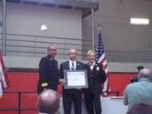

On 11-18-13, we learned that the homeless Delvin Bottor Mamora (9-4-69) was found deceased on Hollywood Blvd, near the 101 Freeway. He was 44 years old. Our first documented contact with him was on 1-19-12. He told us that he was born in San Bernardino Ca. We arrested him for drinking vodka in public at 5925 Hollywood Blvd. This is the area where his body was found.

We have had daily contact with him this year. He slept near the Tommy’s Burger and we would wake him up each morning. On 10-9-13, we received a call of a man sleeping at a table at Tommy’s Burger located at 5873 Hollywood Blvd. Our bike Team responded and they woke him and asked him to leave. He complied, walked outside to a planter, retrieved a bottle of Taaka vodka, and then started drinking. This brand of vodka is very popular on the streets as it is the most inexpensive. He was placed under arrest. Delvin refused all offers for outreach help.
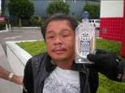
Devlin Bottor Mamora RIP

On 11-18-13, our Officers came across a fatal traffic accident where a car struck an apparent jogger at Franklin and Las Palmas. LAPD Sgt. Ogaz was alone at the scene and asked our Officers for assistance until he could get additional LAPD units to the scene. Our Officers then directed traffic until units arrived.

On 11-22-13, Officers Sterling and Islas went on Foot Patrol. They spoke with Mr. and Mrs. Young from Texaco, Fred and Linda from Victorville and Gus and Byron from San Francisco. Our Officers shared points of interest with these tourists.

On 11-23-13, I attended the annual Home Walk at USC. This is a huge fundraiser with the goal of ending homelessness. My wife Heather, daughters Caitlin and Emily and of course Ellia participated as well. Andrews V/P Bill Farrar also made the scene.
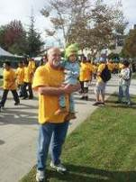
Ellia and Pop Pop

On Saturday night (11-30-13), our late night patrol noticed heavy club activity. They saw many near miss traffic collisions. They also saw three different women vomiting on the sidewalk after leaving the clubs. Oh, the glamour!

On 12-3-13, we received a call of a man causing a disturbance and refusing to leave at the KTLA Studios located at 5900 Sunset Blvd. We contacted O/Nester. It turned out that he is in love with an on air personality and wants to marry her. The studio employee does not share his desires. He was warned strongly by Studio Security, BID Security and the LAPD.
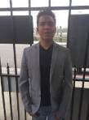
Love Struck

On 12-5-13, we received a call of two men lying on the sidewalk at 6263 Santa Monica Blvd. Officers Mike and Mike responded and found Paramedics on scene talking to Wayne. He kept saying that he wanted to kill himself. LAPD Officers Sparkman and Hargrove were driving by and they stopped to assist. They placed a 5150 hold on Wayne so he could be evaluated.

On 12-5-13, our officers contacted a man at 1218 Vine. He was selling clothing and shoes which he had displayed on the sidewalk and bus bench. He was promptly sent on this way. This type of activity was common at this location before we began patrolling this area. We are determined not to relinquish conquered ground.

On 12-6-13, Joe Salazar and I met with Erin Casey and Erin Krummes from My Friends Place. Due to the large number of violent encounters we have had with mentally ill people, we wanted to explore getting some more advanced training in recognizing and properly responding to these types of situations. We feel that we need more tools to apply to these volatile situations.

We believe that Security, Law enforcement and Social Work Professionals are all trained from different, but complimentary perspectives. We believe that we can share with and learn from one another on how to best intervene with our community members who are living with severe mental health /addiction issues.

If the above paragraph seems more eloquent than my normal writing, it is because I stole it word for word from Erin Casey. Both Erin’s graciously agreed to provide the training and the first session is scheduled for 12-20-13. We have also invited the Santa Monica Police as they are on the cutting edge in dealing with these types of issues. We will

invite the LAPD as well. We plan to have some formal training followed by a give and take between the parties.

Some topics for discussion are;
- How to recognize trauma and mental illness including psychosis.
- What is dual diagnosis (mental illness and substance abuse).
- What is trauma and how does it manifest itself behaviorally? What meaning can you make from behavior and how can you assign meaning so that you don’t take it personally?
- What are some tips on de-escalation that professionals in this field most commonly use?
In any case we will see how this goes. We are hoping that this is the first in a series. The communication between the groups alone would seem to be worth the price of admission.

MEETINGS ATTENDED:
- 11-12-13 LAPD Crime Control Meeting
- 11-12-13 HHOT Outreach Meeting
- 11-12-13 SBID Board Meeting
- 11-14-13 H+H Retail Meeting
- 11-19-13 LAPD Crime Control Meeting
- 11-21-13 Community Impact Meeting
- 11-22-13 Kerry Morrison Addressed Briefing
- 11-23-13 Home Walk Fund Raiser
- 11-26-13 LAPD Crime Control Meeting
- 11-26-13 HHOT Outreach Meeting
- 11-28-13 H+H Retail Meeting
- 12-3-13 LAPD Crime Control Meeting
- 12-5-13 H+H Retail Meeting
- 12-6-13 MFP Training Meeting

OUTREACH:
On 11-11-13, our Officers were surprised when Carl spoke to them in the 6600 block of Hollywood Blvd. He asked if he could approach the car. He was just released after having a 5150 hold placed on him. He was obviously given proper medications as he was lucid and friendly. He declined an offer for help and said that he was staying at the Mark Twain. He then said ‘Well guys, have a good day’.
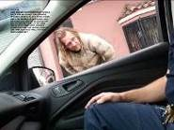
Carl

On 11-12-13, at about 7:00 A.M., Sgt. Patton contacted a woman at 6338 Hollywood Blvd. After getting past a language barrier, he learned that her feet were injured and she was in pain. We considered transporting her to the Saban Free Clinic when Paramedics arrived and took her to the hospital.

On 11-15-13, our Officers found a naked man at the Colony located at 1743 Cahuenga. The LAPD also arrived and said they had a radio call. The man complained of pain to his hands and feet. Paramedics responded and took him to the hospital. The man refused to speak to anyone except our Officer Kanagi. For this reason, she rode in the ambulance with him and got his information for the hospital. His name is Ezekiel Perez. He seemed to be mentally ill and under the influence of an unknown substance.
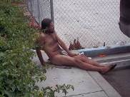
The Naked Ezekiel

On 11-13-13, our Officers Mike and Mike saw LAPD Captains Zarcone and Palka assisting 76 year old Anita at Sunset and Wilcox. The Captains thought she may be suffering from heat stroke. Our Officers gathered her information while the Captains called for Paramedics. Anita was transported to the hospital.
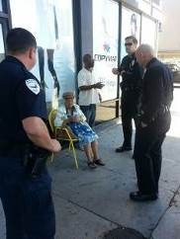
LAPD Captains Zarcone and Palka Join Outreach Effort

On 11-18-13, Officers Mike and Mike contacted the homeless Johnny at Sunset and Cosmo. He is working with Housing Works to get housing. Johnny asked our Officers if they had any idea where he could get some size 12 shoes. They went to the Church of the
Blessed Sacrament and got a pair. They went back, found Johnny and gave him the shoes. He was so surprised and happy that he began to cry.

We have found that simple human kindness can help us build the rapport necessary to help convince someone to make the move to leave life on the streets.
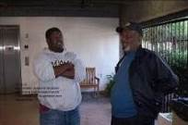
Johnny File Photo

On 11-22-13, Sgt. Patton and Officer Parra found a family of 7 stranded at the Jack in the Box located at 6407 Sunset. The group included 3 women, one man, two toddlers and a baby. They came from Oakland for a job opportunity which did not pan out. Their cellular phone was dead and they were out of options. Our Officers brought one of the women to our office where she charged her phone. Officers Mike and Mike made arrangements with Spencer at the Church and he agreed to take the group in to assist them even though this violated their policies regarding children. Our thanks go out to Spencer and his staff.

On Friday, 11-22-13, Kerry Morrison and staff and Andrews V/P’s Bill Farrar and John Adams attended our briefing. Reggie, Savannah and others from PATH also attended. New H+H GM Lara Saab and her Assistant Director Michael attended as well. We had a maximum deployment so there were about 15 Officers present. We brought in pizza as compensation for forcing the Officers to sit through my speech about our plans for 2014. Kerry and Bill also addressed the troops.

The highlight of the day was the presence of long time homeless and alcohol dependent George. Not long ago, we feared that George would die on
the street. He has been clean and sober for months now and is an inspiration to us. Seeing his success gives us hope that we can help others as well. Kerry and her staff and BID Officers pitched in and bought George a guitar which we presented as a welcome back to the world gift.

George addressed the group and received applause on at least two occasions. We are committed to re-doubling our efforts at outreach and problem solving for 2014. Our Security operation continues to evolve and we look forward to further innovation in the coming New Year.
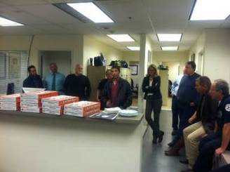
George Addresses the Troops
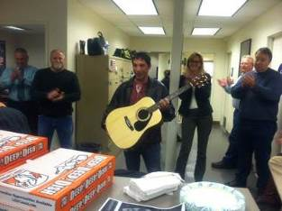
George gets new Guitar

On 11-26-13, we received a call of a man down on the sidewalk at 6015 Sunset Blvd. The man seemed very inebriated. He tried to stand, but then fell striking his head and causing a small contusion. We called Paramedics who responded and took him to the hospital. We will try to learn the man’s name and other information.
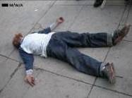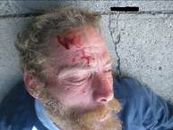
Man Down

On 11-17-13, our Officers Mike and Mike made contact with the homeless Dan at the Jack in the Box located at 6407 Sunset Blvd. The Officers called Reggie from PATH. He responded to the scene and took Dan to a shelter.

On 11-28-13, our Bike Team Officers conducted their first annual BTBB (Bike Team Burger Bash). They bought 20 cheeseburgers at the McDonalds located at 1413 Vine. They then cruised through the BID giving burgers to the homeless. This is great rapport building plus it’s Thanksgiving.
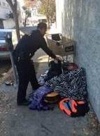
Officer Anderson Brings Burger

On 12-8-13, our Officers found Donald sprawled out on the sidewalk in front of the Loew’s Hotel located at 1755 Highland. He was warned regarding the violation. He said that he is a homeless veteran. We gave him the proper contact information for shelter and services.
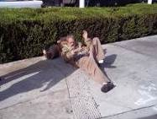
Donald Kickin it

On 12-6-13, Officers Kanagi and Gordon contacted a group of young homeless people causing a disturbance at 6776 Hollywood Blvd. Most were sent on their way. Young mother Raven, along with 7 month old Ezra, were given a referral to “Beyond Shelter” for housing for her and the baby.
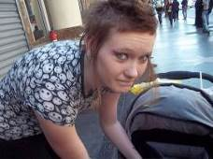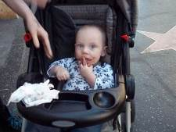
Raven and Ezra

ENFORCEMENT:
In the Hollywood BID we have made a total of 734 arrests. Four hundred and eight were for drinking in public, 57 for urinating in public, 80 for trespass, 10 for illegal vending, 16 for battery, 69 for blocking the sidewalk, 17 for theft, 16 for miscellaneous misdemeanors, and 61 for felonies. We also made 514 homeless referrals, assisted 163 agencies, provided 1447 foot beat patrols for a total of 1840.4 hours, assisted 15028 citizens, handled 3117 radio calls for service and made 8340 business contacts.

In the Sunset BID, we have made a total of 292 arrests. Two hundred were for drinking in public, 28 for urinating in public, 21 for trespass, 6 for battery, 13 for blocking the sidewalk, 3 for theft, 8 for miscellaneous misdemeanors, and 13 for felonies. We also made 330 homeless referrals, assisted 140 agencies, provided 124 foot beat patrols for a total of 111.9 hours, assisted 5158 citizens, handled 1609 radio calls for service, and made 3223 business contacts.

The combined arrest totals for both BIDS are 1026 arrests. Six hundred and eight for drinking in public, 85 for urinating in public, 101 for trespass, 10 for illegal vending, 22 for battery, 82 for blocking the sidewalk, 20 for theft, 24 for miscellaneous misdemeanors and 74 for felonies. We also made a combined total of 844 homeless referrals, assisted 303 agencies, provided 1571 foot beat patrols for a total of 1952.3 hours, assisted 20186 citizens, handled 4728 radio calls for service, and made 11563 business contacts.

Since we began this operation in 2007, we have made 10,032 Private Person arrests, including 552 Felonies. We have responded to 24,034 calls for service.

NOTED ARRESTS:
On 11-12-13, Officers Ayala and Coogle arrested Ladarryle for drinking in public at 6777 Hollywood Blvd. After turning him over to the LAPD we learned that he had an outstanding Felony Parolee at Large Warrant.
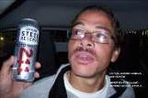
Parolee at Large Ladarryle

On 11-14-13, we received a call of a man causing a disturbance at 1815 Cahuenga. Upon arrival we found long time problem subject Will drinking a beer in front of the location. He was placed under arrest and taken to the LAPD Station. We then learned that he had Felony Warrant for possession of methamphetamines.

BID Security’s first documented contact with this suspect was on 5-5-04 when he was warned for trespassing. We have 58 FI cards on file. He has generated numerous calls

for service and we have arrested him many times. We have found him to be hostile and violent at times. He is an excellent candidate for a Stay Away Order.
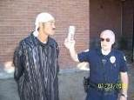
Long Time Problem Will

On 11-16-13, we received a call of a theft about to occur at the Gap located at 6801 Hollywood Blvd. Security Agent Burns said that two men were removing the security tags on clothing and placing the items into a backpack. They had been in the store earlier and had made no purchases. She believed that they had stolen items at that time.

We responded in force with two Bike Teams, two BID Officers and a Supervisor. We formed a perimeter outside of the store. Justin and Matthew exited the store with the stolen property. Agent Burns attempted to make a Private Person’s Arrest, but the suspects refused to comply. Our Officers then made the arrest for her.

Based on all of the above and also on Burn’s statement that the suspect’s did not have any means to pay for the items, our Officers formed the opinion that the suspects had entered the location with the intent to steal. The Theft charge was then changed to Burglary.
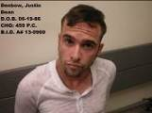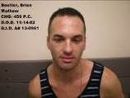
Justin and Matthew

On 11-17-13, Officers Sterling and Kanagi were flagged down at 5873 Hollywood Blvd. A man named Yonce was screaming for help. He said that the suspect hit him with a bicycle kick stand and that she had almost hit his dog as well.

Our Officers stopped. Suspect Linda approached Kanagi while screaming at her. It appeared that she was going to strike her with the kick stand. Officer Kanagi put her hand on the butt of her holstered weapon and ordered Linda to drop the weapon. The suspect then said ‘Go ahead. I want to die today’. Her boyfriend Roder then told her to put it down.

Linda then approached him and tried to hit him in the face with the kick stand. He ducked and then wrestled it away from her. Our Officers then grabbed her and guided

her to the ground. They held her down while they waited for back-up. She was eventually handcuffed although she continued to fight. She also spit on one Officers leg.

As often happens in these emotional situations, the boyfriend changed from the role of victim to that of his girlfriend’s protector. He had to be restrained by our Officers and LAPD Officers who had also arrived at the location.

After the action was over, Officer Kanagi noticed that her wrist and forearm were beginning to swell. Paramedics were called and they transported her to Kaiser. Her arm was X-rayed and the injury was determined to be a bruise only.

LAPD Officers took custody of the suspect who was charged with Battery.

On 11-20-13, our Bike team found Michelle sleeping on the sidewalk at 6434 Yucca. She woke up and immediately started cursing our Officers. She also threatened them. She approached Officer Ramirez and tried to pull his bicycle away from him. He pushed her back and the team then placed her under arrest. The cause of her anger and violence is unknown to us. We were unable to get a photograph of her as she refused to cooperate.

BID Security’s first documented contact with Michelle was on 10-25-94 when Officers contacted her at Highland and Yucca. At that time she was on Parole for GTA and Burglary and claimed to be a member of the ‘Crazy Ladies’ gang. Michelle said that she came here from Leominster Ma. We arrested her many times over the years, mostly for drinking in public.
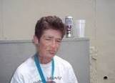
Michelle from 7-14-13 Arrest

On 11-21-13 we arrested Brian for Defrauding an Innkeeper at Kitchen 24 on Cahuenga. We also arrested him on 11-12-13 and 11-17-13 for the same charge. He has never had money with him so it is obvious that these crimes are planned. Looks like another good candidate for a stay away order.
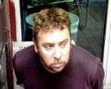
Free Feeder Brian

On 11-30-13, at about 2:20 A.M., our late night Patrol Officers Merkens and Coppola saw a group of men arguing in front of the Juicy Burger located at 6741 Hollywood Blvd. A customer said that suspect Armando had pushed him from behind for no reason. Our Officers then heard the suspect use the N word to a passing group almost causing a fight to break out. He then called another group “Dumb Armenians”. We called for the LAPD.

Before the LAPD arrived, the suspect approached our Officers and it appeared that he planned to attack them. They then placed him under arrest for causing a disturbance. LAPD Officers Araujo and Castejon arrived and took custody. The suspect started kicking and then went limp as they tried to place him in the patrol car. They finally loaded him in with the help of back-up Officers.

The suspect promptly started kicking the rear passenger window, breaking the frame. The charge of 594(a) (1) PC was added to his charges. In a blatant attempt to add insult to injury, he also threw up in the back of the Patrol car.

On 11-26-13, our Officers contacted Willie at the 7-11 located at 1810 Cahuenga. He poured out the beer he was drinking as the Officers approached. He then started shouting profanities at them saying they should stop harassing him and threatening to kill them. He walked off still yelling threats.

Our first documented contact with Willie was on 4-26-12 when he set off a false fire alarm at 6290 Sunset Blvd. the LAPD responded and placed a 5150 hold on him. He told us that he came here from New Orleans. We arrested him for threats on 3-23-12 and drinking on 5-3-12. We arrested him for trespass on 6-6-12 and a 5150 hold was placed on him. We arrested him for drinking on 8-15-12, 7-26-13, 8-9-13and 8-23-13. We arrested him for drinking and battery on 9-6-13. We took him in again for drinking on 9-7-13 and 10-14-13.

Willie splits his time between both BIDs and is a constant problem. He is hostile, violent and mentally unstable.
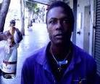
Photo of Willie from 10-14-13

On 11-28-13, Officers Melvin and Cox made arrest number 1000 for 2013. The honor went to Ronald who was drinking Borski Vodka at 6130 Sunset Blvd.

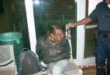
Ron and his Borski

On 12-3-13, we received a call of a female causing a disturbance at the L.A. Film School and refusing to leave. Upon arrival we learned that the female was Shalea and that she was a student at the school. She was upset about her schedule and refused to calm down. Her Counselor then asked her to leave. She refused. Employees signed a PPA and asked us to take the suspect into custody.

Despite numerous warnings, she refused to cooperate. She was guided to the floor by our Officers and handcuffed. There were no injuries to any party. Shalea then claimed that our Officers had kicked her in the face, loosening an upper tooth. She refused medical treatment.

There were numerous witnesses to the arrest including Film School Security Director Mike Arminio. I spoke to him and he assured me that the suspect was not kicked during the arrest. He also provided us with video of the arrest which also shows that no undue force was used.

Shalea
On 12-4-13, we received a call of a man creating a problem at the Vibe Motel located at 5920 Hollywood Blvd. Manager Jason Walkin said that the suspect would follow patrons into the motel and then go straight to the computer room. He would then access the internet and watch porn movies. He would then knock on patrons doors and ask to be let into their rooms.

Sgt. Reyes and Officer Melvin responded and gave creepy suspect Pablo Mayorga a free ride to the LAPD Station.
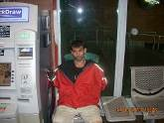

DEPLOYMENT:
During this period, we worked from 6:00 A.M. to 8:00 P.M on Monday through Saturday. On Sunday we worked from 10:00 A.M. until 6:00 P.M. On 10-4-13 we started another late night patrol experiment. We put three two Officer unarmed teams on Hollywood Blvd. from 9:00 P.M. until 3:00 A.M. They are supported by two armed Officers in a vehicle. Their mission is to observe and report suspicious and unlawful activity to the LAPD. This is a 14 week trial. The assignment has been going well with great communication between BID Security and the LAPD.

TRAINING UPDATE:
During this period, our officers had live fire training in night time conditions. They also received training in legal update, blood borne pathogens and civil liability issues.

